

Bangladesh University of Engineering and Technology

**Course No:** EEE 212

**Project Report Submission**

**Project Title:** Image Processing Toolbox

**Name** : 1) Abrar Al Shadid Abir (ID: 1906030)

2) Vivek Chowdhury (ID: 1906031)

**Section: A1**

**Department**: EEE

The project is an aggregate of several image processing functionalities. It can perform:

1. Grayscale conversion
2. Binary conversion
3. 4 types of filtering: Mean, Median, Max, Min
4. Edge detection using either Sobel or Prewitt operator
5. Histogram equalization
6. Log transformation
7. Power law transformation with variable gamma(from 0 to 4)
8. Segmentation using either adaptive or otsu

Overview of the program’s layout:

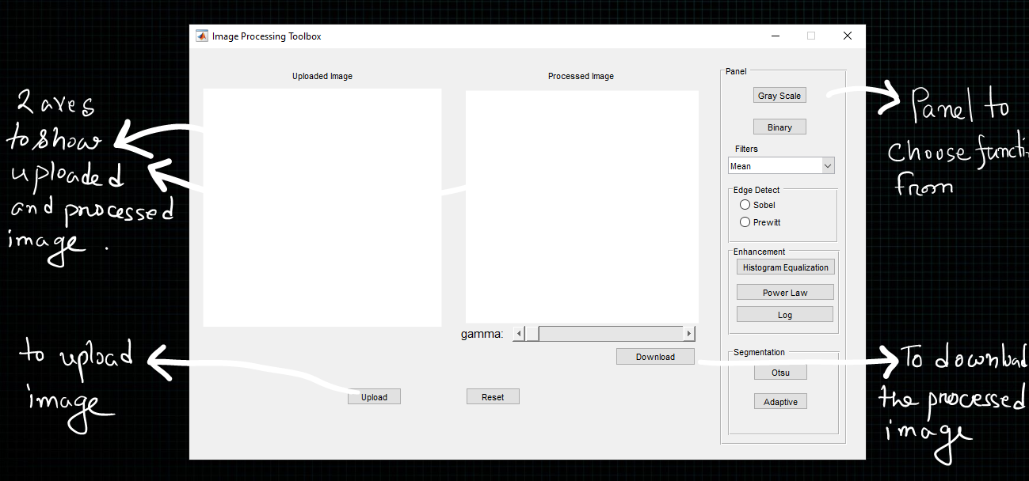

Demonstration of functionalities:

Gray Scale:

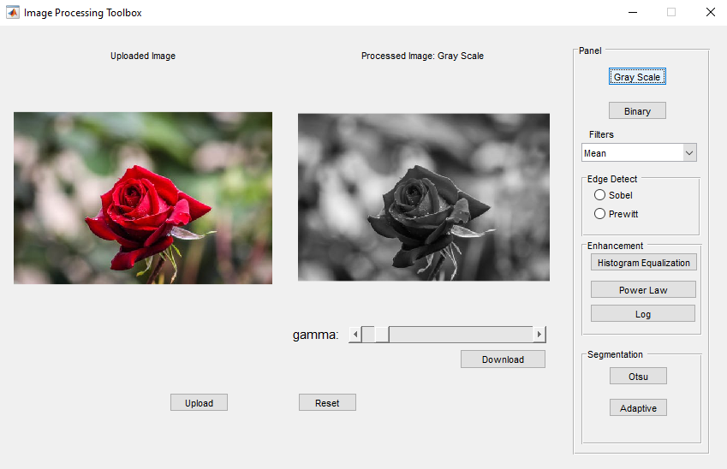

Binary:

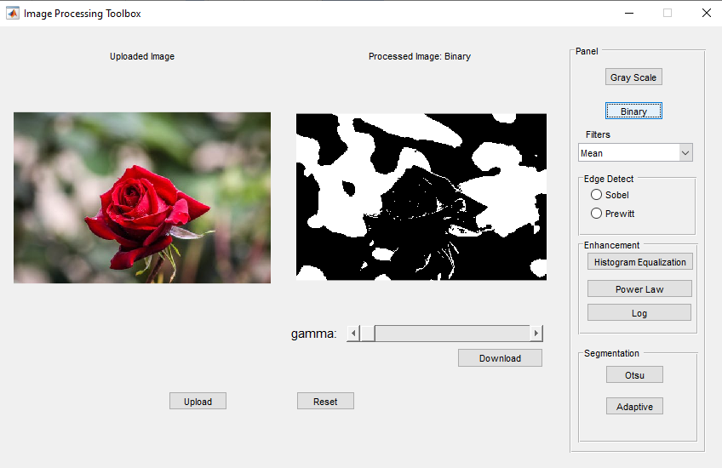

Max Filter:

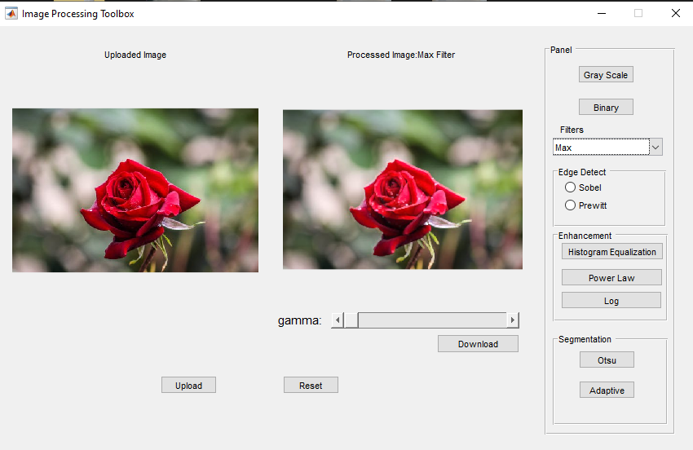

Min filter:

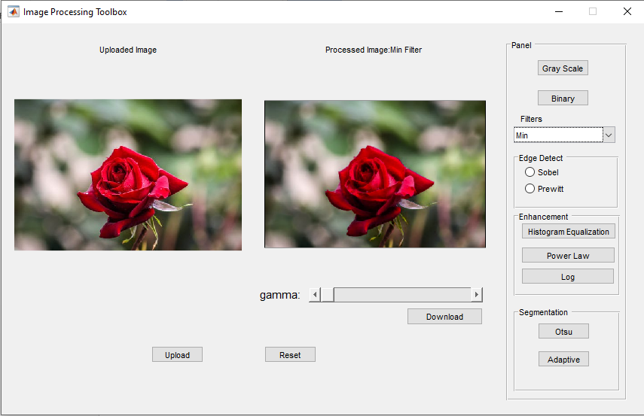

Median filter:

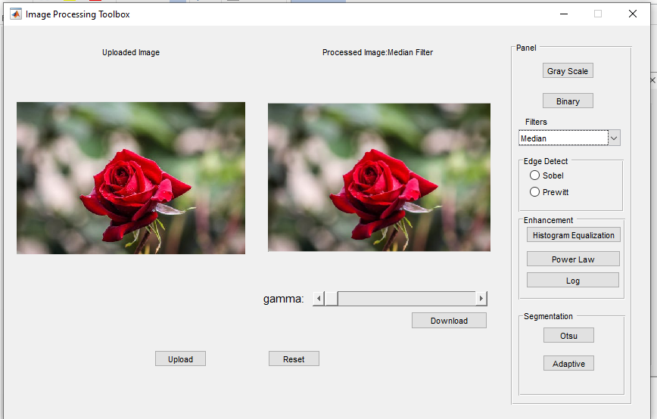

Sobel:

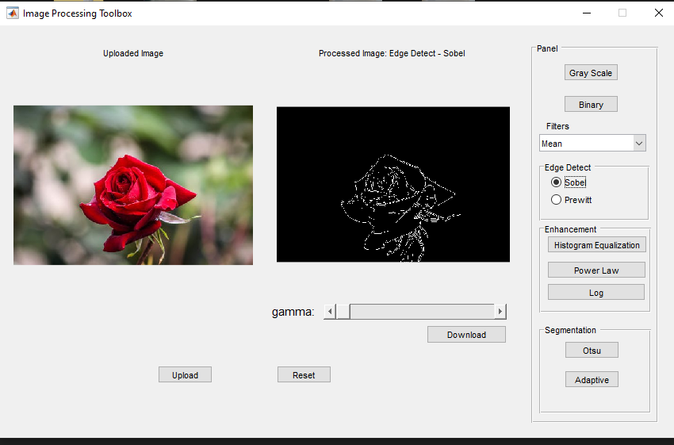

Histogram equalization:

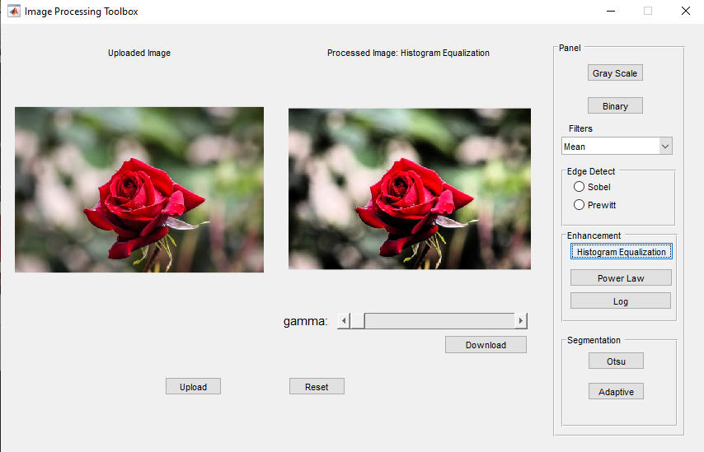

Power law transformation:

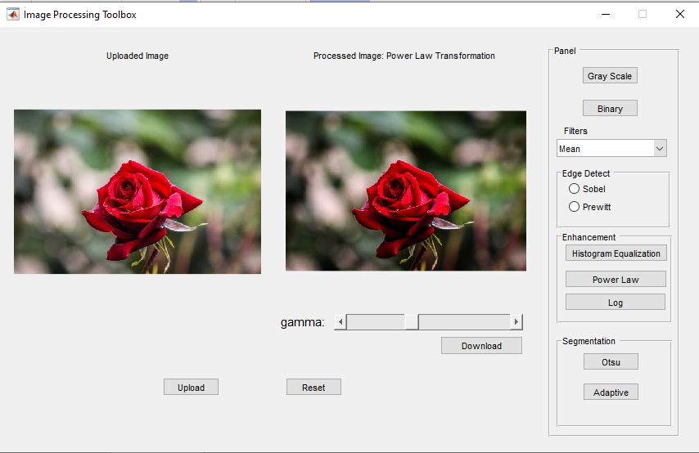

Adaptive:

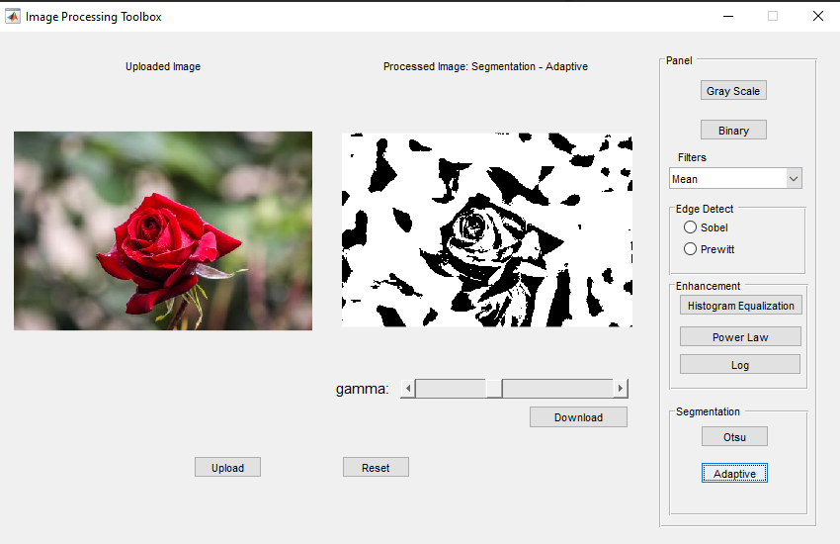

The project is almost finished. Little tweaking here and there are still going on with the project.